Freight Rate Prediction: Approach and Validation
Machine Learning Engineer assessment. Data split, validation, and the December chart.

1. The task
I trained on 48,000 labeled loads from 1 January to 31 October 2025 (train_test.csv) and predicted posted_rate for the 12,000 loads in validation.csv, which are dated November and December. The final score is calculated by Spotter after submission, so I could not check it myself. Because of that, the way I split and validated my own data mattered more than any single modelling choice.

2. Data split and validation
Every validation load is later in time than every training load, so the real job is forecasting forward. I therefore validated forward in time with an expanding window. Each fold trains only on earlier months and tests on the next two:
Fold | Train on | Test on
A | Jan to Apr | May to Jun
B | Jan to Jun | Jul to Aug
C | Jan to Aug | Sep to Oct

Fold C looks most like the final task (train through the autumn, predict the next months), so I paid most attention to it. The final model is refit on all ten months. Training labels with impossible rates (section 3) are removed before fitting, and the test folds are cleaned the same way, so the numbers below describe loads with plausible labels.
The results, in dollars on the held-out months:
Fold | MAE | RMSE | R2 | MAPE %
A: Jan-Apr to May-Jun | 68.36 | 165.99 | 0.986 | 2.71
B: Jan-Jun to Jul-Aug | 42.21 | 88.91 | 0.996 | 1.83
C: Jan-Aug to Sep-Oct | 60.71 | 162.43 | 0.986 | 2.54
Mean | 57.09 | 139.11 | 0.989 | 2.36
Table 1. Forward-in-time validation of the final model.
My first attempt used one 80/20 time split (train to 31 Aug, test 31 Aug to 31 Oct) and gave MAE 82.83, RMSE 284.73 and MAPE 3.78%. That version used quote_signal and a multiply-by-five repair of bad labels. The second version scores MAE 60.71 and MAPE 2.54% on Sep to Oct. The two are not strictly comparable (different label handling and slightly different test rows), but the improvement is large and the direction is clear.

3. What I found in the data
- Rate per mile (rate divided by distance) is the useful view. Most loads sit around 1.7 to 3.2 dollars per mile, and it varies by distance and equipment.
- Impossible rates: 329 loads are below 1 dollar per mile and 317 are above 5. There is a clear empty gap between these and the bulk, so I treat them as entry errors. That is 646 rows, or 1.35%. I dropped them from training.
- I first tried repairing them by multiplying or dividing by 5. That does not work: the low rows multiplied by 5 have a median of 3.03 dollars per mile (normal loads: 2.15, and the repaired rows spread out much wider), while the high rows divided by 5 land at 1.54. The errors are not a single fixed factor, so repairing them would add new noise. Dropping is the safer choice.
- Weight has 300 missing values and 292 negative values in training (165 and 145 in validation). The negatives look like sign errors, so I use the absolute value. Missing weights stay missing, with a flag, and the model handles them. About 1,200 loads sit exactly at 47,500 lb, which looks like a cap.
- market_index has 374 missing values in training and 249 in validation. It behaves like a daily level plus small random noise, so I fill a gap with that date's average from the same file. No labels are used for this.
- 736 lanes in the validation file never appear in training, and eight cities never appear at all (Allentown, Charlotte, Chicago, Jackson, Knoxville, Laredo, Norfolk and San Diego). Those cities are in 1,447 validation rows, 12.1% of the file. So I do not encode lanes. The model uses the pickup and delivery city, coordinates, direction and distance, which generalise to new city pairs and, through coordinates, to new cities.
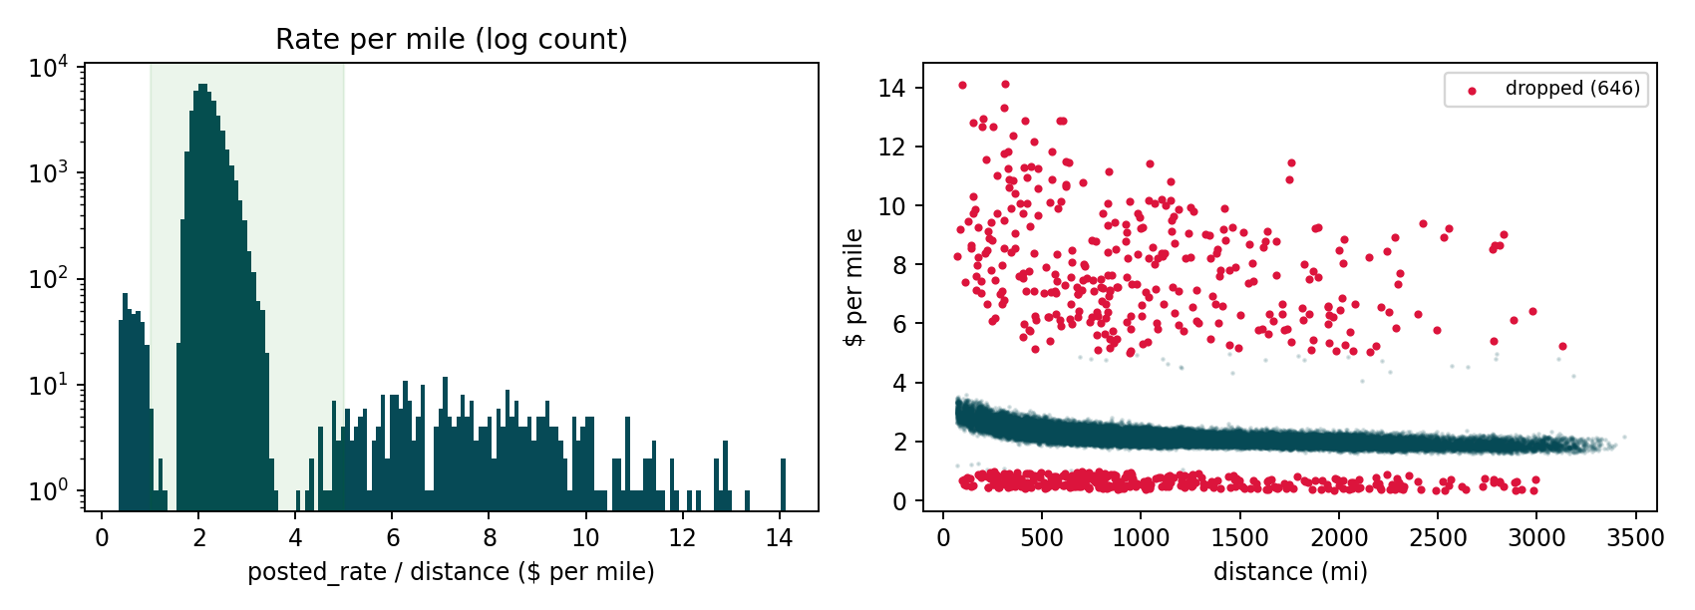
Figure 1. Rate per mile. Red points are the dropped rows.
To see what unseen cities cost, I hid 8 cities from training (two random draws), trained on January to August without any load touching them, and tested on September and October:
Group | Draw | Loads | MAE | MAPE %
Loads with a held-out city | 1 | 1,719 | 86.85 | 3.65
All other loads | 1 | 7,667 | 60.15 | 2.53
Loads with a held-out city | 2 | 2,248 | 63.00 | 2.63
All other loads | 2 | 7,138 | 61.43 | 2.58
Table 2. Error on loads touching cities the model never saw in training.
The cost is real but small: error on those loads was clearly higher in the first draw and about the same in the second. The model copes with new cities by using their coordinates, but I would expect the roughly 12% of validation loads that involve them to be a little less accurate.

4. quote_signal
quote_signal looks very predictive, but its relationship with the rate per mile changes between months (Figure 2). In January to March, June and September it follows the rate almost perfectly (correlation about +0.95 to +0.96). In April, May, July and October it runs the other way (about -0.97 to -0.99), and through August it is noise. My first model used it, and it also fed three interaction features.
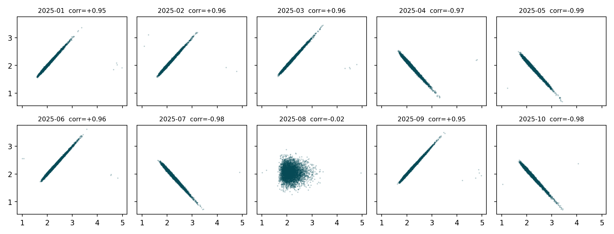
Figure 2. quote_signal against rate per mile, month by month (Jan to Oct).
For November and December I can check what it does without any labels. The correlation between quote_signal and my predicted rate per mile, from a model that does not use it, is 0.001 for November and -0.016 for December, so it is effectively noise there. Its daily average also barely moves in the validation file (standard deviation 0.016, against 0.129 in training). A model trained on it would be leaning on something that is not there at prediction time, so the final model does not use it.

5. Model
The rate level drifts slowly through the year in a way market_index does not explain. For example, September had the lowest market_index of the year (0.893), yet its average rate per mile (2.203) was higher than January's (2.070 at a market_index of 0.927). Trees cannot extrapolate a drift like that into new months, so I split the model into two parts and fit them in alternating rounds:
- Static part: HistGradientBoosting on log(rate), using distance, weight, equipment, pickup and delivery city, coordinates and direction. It has no date or market columns, so it only learns what depends on the load itself.
- Level part: a linear term for market_index (fitted slope 0.110 on log rate), estimated with 14-day block effects so the slow drift does not bias it, plus a single constant. The constant is the average leftover level over the last 60 training days (-0.0953), and it is carried forward to the future.
I chose to carry the latest level forward rather than fit a time trend, because projecting a trend two months ahead is a bigger assumption than assuming the level stays near where it was.

6. December chart
The chart comes from the provided score.py, using the 31 completed rows (Lexington to Fort Wayne, 360 miles, Dry Van, 32,000 lb). Since only the date changes, I needed a date-specific market level. I used each December date's average market_index from validation.csv (a feature column, not a label), and took the city coordinates from the training data.
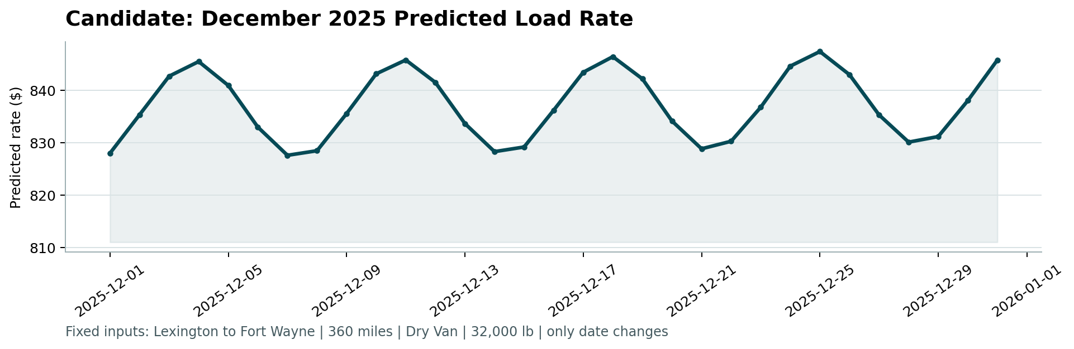
Figure 3. candidate_december.png, produced by score.py.
Predictions run from $827.59 to $847.36 (about 2.30 to 2.35 dollars per mile). The weekly rise and fall comes from market_index in the validation file, which follows a seven-day cycle (it peaks on Thursdays in December). The whole swing is about 2.4%, which fits the small effect market_index has on rates.

7. Limitations
- The training data stops at October, so a real holiday effect in late December is not something the model could learn.
- About 12% of the validation loads involve a city the model never saw in training. The hold-out test above suggests a small loss in accuracy on those loads, but only two random draws were tested.
- Carrying the level forward assumes November and December stay near the September and October level. If the level keeps drifting, errors will be larger than in the folds above.
- I do not know how the final score treats impossible labels. If the validation set contains such rows too, no model can predict them from the features.
- My folds use two-month test windows. Different fold boundaries could be tried to check the result is stable.

8. Reproducing this
Everything is in the Colab notebook in the repository (freight_rate.ipynb). Run the cells in order; the README lists them. The notebook fits the model on all labeled data, writes validation_predictions.csv, runs the diagnostics behind the figures and tables here, writes the December file, and runs score.py.

